**Mid-Semester Internship Report**

MapmyIndia, Bengaluru



by

Name - Abhinav Gupta Id - 2016A7PS0011P



**Birla Institute of Technology and Science, Pilani**

(September’19)

**Table of Contents**

**CONTENTS PAGE**

1. Abstract 4
2. Response option sheet 5
3. Acknowledgements 6
4. Introduction 7
5. PART I

1.1 Camera Parameters 8

1.2 Intrinsic Calibration 10

1.3 Extrinsic Calibration 15

1. PART II

2.1 ApolloScape 16

2.2 YOLO 19

1. References 24

**A REPORT**

on

**PART 1** - Intrinsic and Extrinsic Camera Calibration

**PART 2** - Analysing various open datasets by Baidu Apollo for autonomous vehicles and finding appropriate segmentation and object detection architectures useful for implementing HD Maps.

by

Abhinav Gupta

2016A7PS0011P

B.E. (Hons.) Computer Science

***Prepared in partial fulfilment of the***

Practice School II Course

at

MapmyIndia, Bengaluru

a Practice School II Station of

**BIRLA INSTITUTE OF TECHNOLOGY AND SCIENCE, PILANI**

(September, 2019)

**BIRLA INSTITUTE OF TECHNOLOGY AND SCIENCE**

**PILANI (RAJASTHAN)**

**Practice School Division**

**Station:** MapmyIndia **Centre:** Bengaluru

**Duration:** July’19 - December’19 **Date of Start:** July 8, 2019

**Date of Submission:** September 16, 2019

**Title of the Project:**  Intrinsic and Extrinsic camera calibration, Analysing Paidu Apollo Datasets and finding segmentation and object detection architectures useful in implementing HD Maps.

**ID No./Name(s)/:** 2016A7PS0011P, Abhinav Gupta, B.E. (Hons.) Computer Science

**Discipline(s) of the**

**Student(s)**

**Name(s) and:** Muraleedhara Navada,

**Designation(s)**

**of the expert(s)**

**Name(s) of the:** Seetha Parmeswaran

**PS Faculty**

**Key Words:**

**Project Areas:** Computer Vision, AI

**Abstract:**

High Definition Maps or HD Maps for short are particularly built for self-driving purposes. These maps specifically have extremely high precision at centimeter-level. 3D computer vision and Deep Neural Network are the technologies driving the development of high- definition live maps for self-driving cars. The very basic problems for this are segmentation and detection of road object and lanes, requiring large and diverse datasets.

Apolloscape is an open, collection of datasets provided by Apollo, chinese autonomous car project, aimed at solving these problems.

Signature(s) of Student(s) Signature of PS Faculty

Date

**BIRLA INSTITUTE OF TECHNOLOGY AND SCIENCE**

**PILANI (RAJASTHAN)**

**PRACTICE SCHOOL DIVISION**

# **Response Option Sheet**

Station: **MapmyIndia** Center: **Bengaluru**

ID No. & Name(s): **2016A7PS0011P** & **Abhinav Gupta**

Title of the Project: **Intrinsic and Extrinsic camera calibration, Analysing Baidu Apollo Datasets and finding segmentation and object detection architectures useful in implementing HD Maps.**

Usefulness of the project to the on-campus courses of study in various disciplines. Project should be scrutinized keeping in view the following response options. Write Course No. and Course Name against the option under which the project comes.

Refer Bulletin for Course No. and Course Name.

|  |  |  |
| --- | --- | --- |
| Code No. | Response Option | Course No.(s) & Name |
| 1. | A new course can be designed out of this project. |  |
| 2. | The project can help modification of the course content of some of the existing Courses |  |
| 3. | The project can be used directly in some of the existing Compulsory Discipline Courses (CDC)/ Discipline Courses Other than Compulsory (DCOC)/ Emerging Area (EA), etc. Courses |  |
| 4. | The project can be used in preparatory courses like Analysis and Application Oriented Courses (AAOC)/ Engineering Science (ES)/ Technical Art (TA) and Core Courses. |  |
| 5. | This project cannot come under any of the above mentioned options as it relates to the professional work of the host organization. |  |

_______________ ________________

Signature of Student Signature of Faculty

Date: September 16, 2019 Date: September 16, 2019

**Acknowledgements**

* Mr. Muraleedhara Navada, for his constant guidance, regular feedbacks, reviews and suggestions.
* Ms. Seetha Parmeswaran for her guidance during initial days of the internship and being helpful throughout the period.
* The software and AI team, for always being helpful and sharing their experiences regarding the work related to our project.
* Poetry Corner, the weekly presentation platform for keeping us updated on various latest technologies and the work done in the organization. We have been learning here a lot and hope to continue to, for the remaining of the period of our internship.
* All the employees of the organization for providing a wonderful environment to work in.

**Introduction**

As is our work, this report has been divided in 2 parts. The first part involves the calculation of intrinsic and extrinsic parameters of cameras while the second revolves around analysis of Baidu Apollo datasets and some AI architectures for segmentation and detection of road obstacles and lane markings.

**PART I**

In computer vision, geometry describes the structure and shape of the world. It concerns measures such as depth, volume, shape, pose, disparity, motion or optical flow. Simple geometry can be used to study the formation of images by projection through a camera, simple mathematical rules to study the relation between a point in the world and the same point as seen in an image. Calculating various parameters like focal length of the camera, projection information and pose information of the camera can enable us to find depth of various objects in images, in the real world, and thus potentially, recreating the whole 3D world from images, again, by using simple geometry!

**PART II**

HD Maps are used by autonomous cars to provide very high(cm level) accuracy, which is impossible to be achieved by using GPS. 3D computer vision and Deep Neural Networks are the technologies driving the development of high- definition live maps for self-driving cars. Apollo, chinese company Baidu’s autonomous car platform is such an effort. Apolloscape is a large open dataset released by Baidu to promote research on various challenges involved in the task such as road obstacle detection, lane segmentation, trajectory prediction etc.

This part involves an in depth analysis of all the parts of the dataset and attempting to find appropriate segmentation and detection architectures to solve the problem offered by each of the dataset.

**PART 1 - Intrinsic and Extrinsic Camera Calibration**

***1.1 Intrinsic and Extrinsic Camera Parameters***

### Basic Pinhole camera Model

The pinhole camera model is used to understand the formation of images. In this model, a scene view is formed by projecting 3D points into the image plane using a perspective transformation.

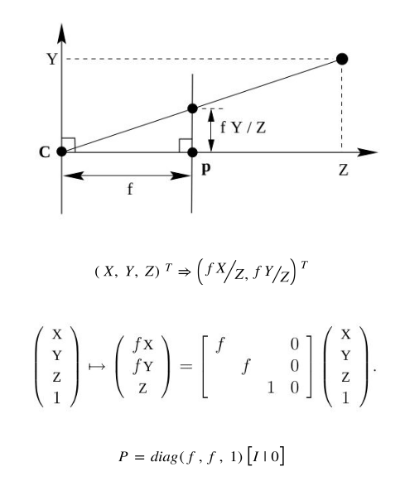

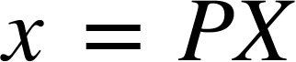 represents the general relation between 2D image coordinates of a point and its corresponding 3D world coordinates where,

*x* is the 2D image coordinates vector

*X* is 3D world coordinates vector

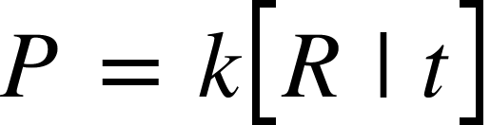

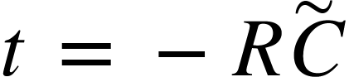, is translation vector

*R* is the rotation matrix

is camera coordinates vector

and *k* is the intrinsic camera matrix

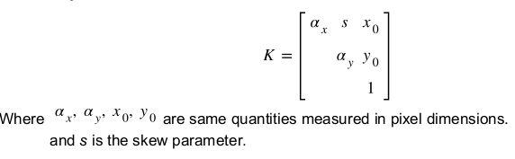

where, 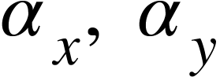 are focal lengths of camera on each axis

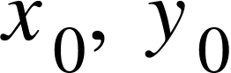 are principal point coordinates

and *s* is the skew parameter

All the above parameters involved with *k* compose the **intrinsic parameters**.

Apart from these, distortion coefficients can also be calculated to undistort the image if required.

The calculation of *R*, *t* is called the **extrinsic calibration.**

### Epipolar Geometry and Fundamental Geometry

The epipolar geometry between two views is essentially the geometry of the intersection of the image planes with the pencil of planes having the baseline as axis (the baseline is the line joining the camera centres).

### imageFundamental Matrix

The fundamental matrix(F) is the algebraic representation of epipolar geometry. For an image point x and its corresponding point in the other image x',



***1.2 Intrinsic Calibration, using Checkerboard***

A simple flowchart to depict the whole process of intrinsic calibration of camera using checkerboard images -

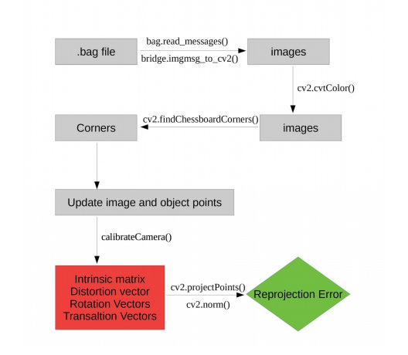

### BAG Files (Preprocessing)

A bag is a file format in ROS for storing ROS message data. Bags -- so named because of their .bag extension -- have an important role in ROS, and a variety of tools have been written to allow you to store, process, analyze, and visualize them. Bags are typically created by a tool like rosbag, which subscribe to one or more ROS topics, and store the serialized message data in a file as it is received. These bag files can also be played back in ROS to the same topics they were recorded from or even remapped to new topics.

We can use the following command to get the details of a bag file: rosbag info foo.bag The output might look something like this:

### Image Extraction

The images contained in the bag file can be extracted using the below given code snippet: Command to run the below code: python program_name.py bag_file.bag path_name image_topic bag_file: name of the bag file path_name: path of the directory where images will be stored. image_topic: topic of the image e.g. /frontNear/left/image_raw/

### 

Run the above code and store the corresponding images in the left and right directories(based on the topics of the messages). Note that the directory for storing the left and right images needs to be created before running the code.

### Important Functions Used

* ***compare_ssim***: Compute the mean structural similarity index between two images.
* ***cv2.findChessboardCorners***: Finds positions of the internal corners of the chessboard. Returns a boolean value depending on if the given shape of corners are found, also returns location of the corners if true.
* ***cv2.cornerSubPix***: The function iterates to find the sub-pixel accurate location of corners or radial saddle points.
* ***cv2.drawChessboardCorners***: Renders the detected chessboard corners.
* ***cv2.calibrateCamera***: Finds the camera intrinsic and extrinsic parameters from several views of a calibration pattern. Returns the rotation and translation matrix corresponding to each pattern. Also returns the camera intrinsic and distortion vector corresponding to lowest reprojection error.
* ***cv2.projectPoints***: Projects 3D points to an image. Used for calculating the reprojection error.
* ***cv2.norm***: Calculates the absolute or relative difference norm between the given image matrices.

### Results

The algorithm takes 40 patterns from the given sample to calibrate the given camera. To cover all the possible orientations of the checkerboard, the selected sample images must be different in orientations. Three techniques have been used to select such samples- ***Simply selecting first 40 images***: Very low reprojection error suggests a possibility of images with similar orientations of the board been selected for calibration. Therefore, a technique to select “good” images from the sample is required.

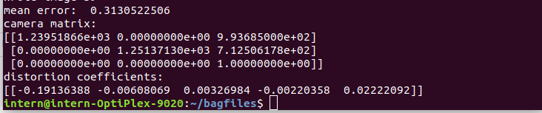

***Skipping a few images after each image***: Another approach we came up with is to skip about 20 to 25 images after selecting one so as to keep the variation amongst the selected images. The results obtained on including every 30th image are: 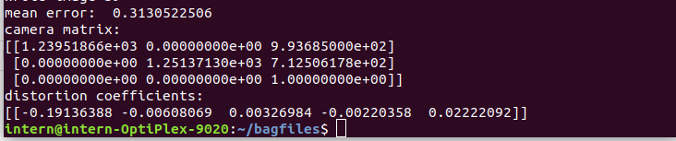

**a. Results with threshold SSIM = 0.65:**

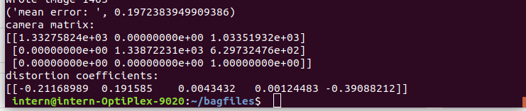

**b. Results with threshold SSIM = 0.62:**

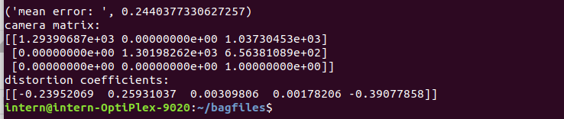

**A plot of threshold value of ssim of selected images(X) against the reprojection error(Y) -**

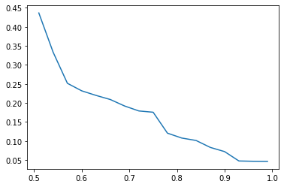

***1.3 Extrinsic Calibration, using ArUco Markers***

A simple flowchart to depict the process of extrinsic calibration of stereo cameras -

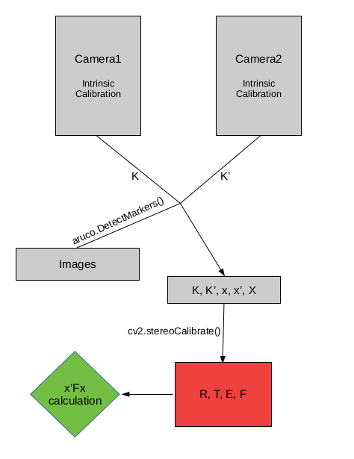

### Images

The images used for the extrinsic calibration of the cameras are images of an ArUco marker on a cardboard, as shown below,

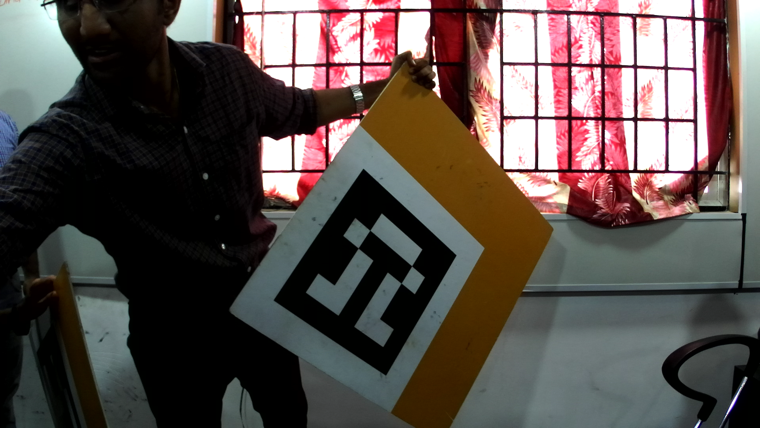

### Important Functions

* ***aruco.DetectMarkers()***: Function from the aruco library of OpenCV, detects the corners of the aruco marker and returns the id of the aruco marker along with image coordinates of the corners of the marker.
* ***cv2.stereoCalibrate()***: Given the camera matrices, object points and the corresponding image points in images from both of the stereo cameras, it calculates the R, T, E, F i.e. Rotation Vector, Translation Vector, Essential Matrix and the Fundamental Matrix respectively. R and T define the extrinsic calibration parameters between the two cameras.

### Verification

The results can be verified by calculating the value of-

**x’ F x = 0**

which is supposed to be equal to zero according to the standard fundamental matrix equation. Closer the value to 0, accurate are the results. x' and x in the above formula are the corresponding image coordinates in second and first image respectively.

**PART 2 - AI**

***2.1 ApolloScape***

### ApolloScape Datasets

ApolloScape, part of the Apollo project for autonomous driving, is a research-oriented project to foster innovations in all aspects of autonomous driving, from perception, navigation, to control. It hosts open access to semantically annotated (pixel-level) street view images and simulation tools that supports user-defined polices. List of various Apolloscape Datasets -

1. Scene Parsing
2. 3D Car Instance
3. Lane Segmentation
4. Self Localization
5. Trajectory
6. 3D Lidar Object Detection and Tracking
7. Stereo

### Other Apollo Datasets

1. Laser Point Cloud Obstacle Detection and Classification
2. Traffic Light Detection
3. Road Hackers
4. Image-Based Obstacle Detection and Classification
5. Obstacle Trajectory Prediction
6. Scene Analysis
7. Apollo-SouthBay

### Scene Parsing(ApolloScape)

For various autonomous car applications like 2D/3D scene understanding, localization, transfer learning and driver simulation.

**Class Labels -** 25 labels, 28 more for lane markings.

**Labeling Process -** 2 stages:

* 3D labeling to handle static background objects
* 2D labeling to handle moving objects

Wrong annotations fixed manually.

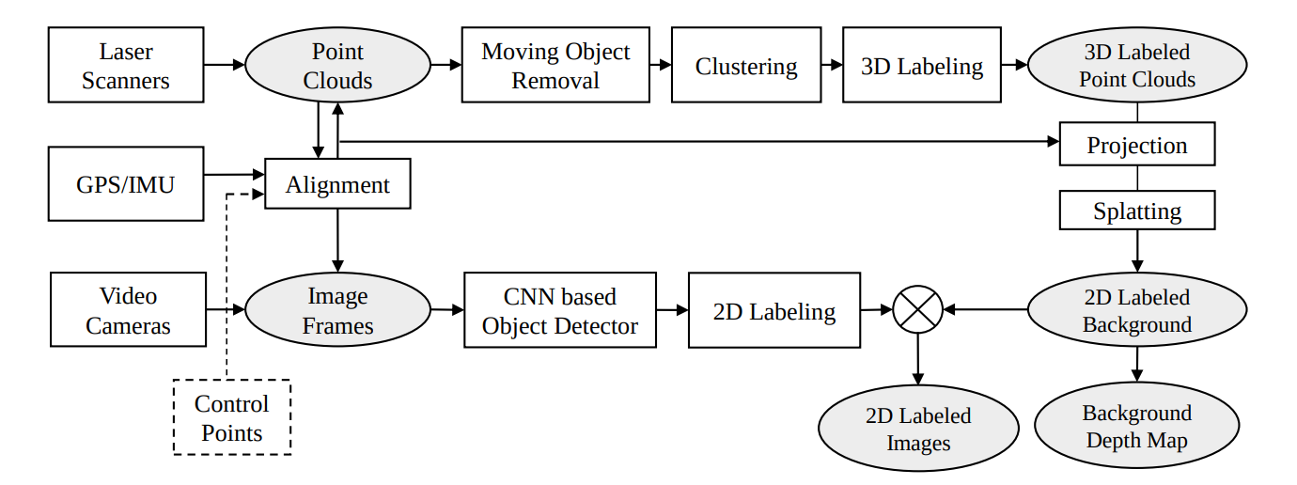

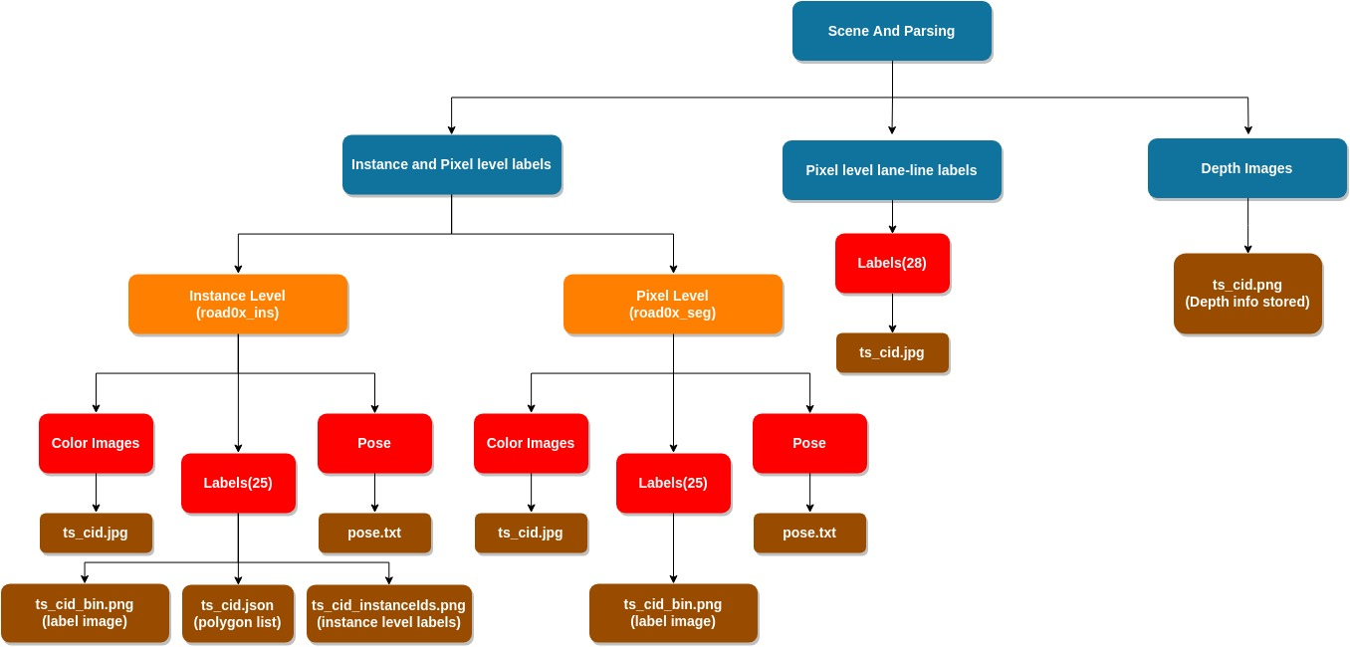

Scene Parsing dataset structure

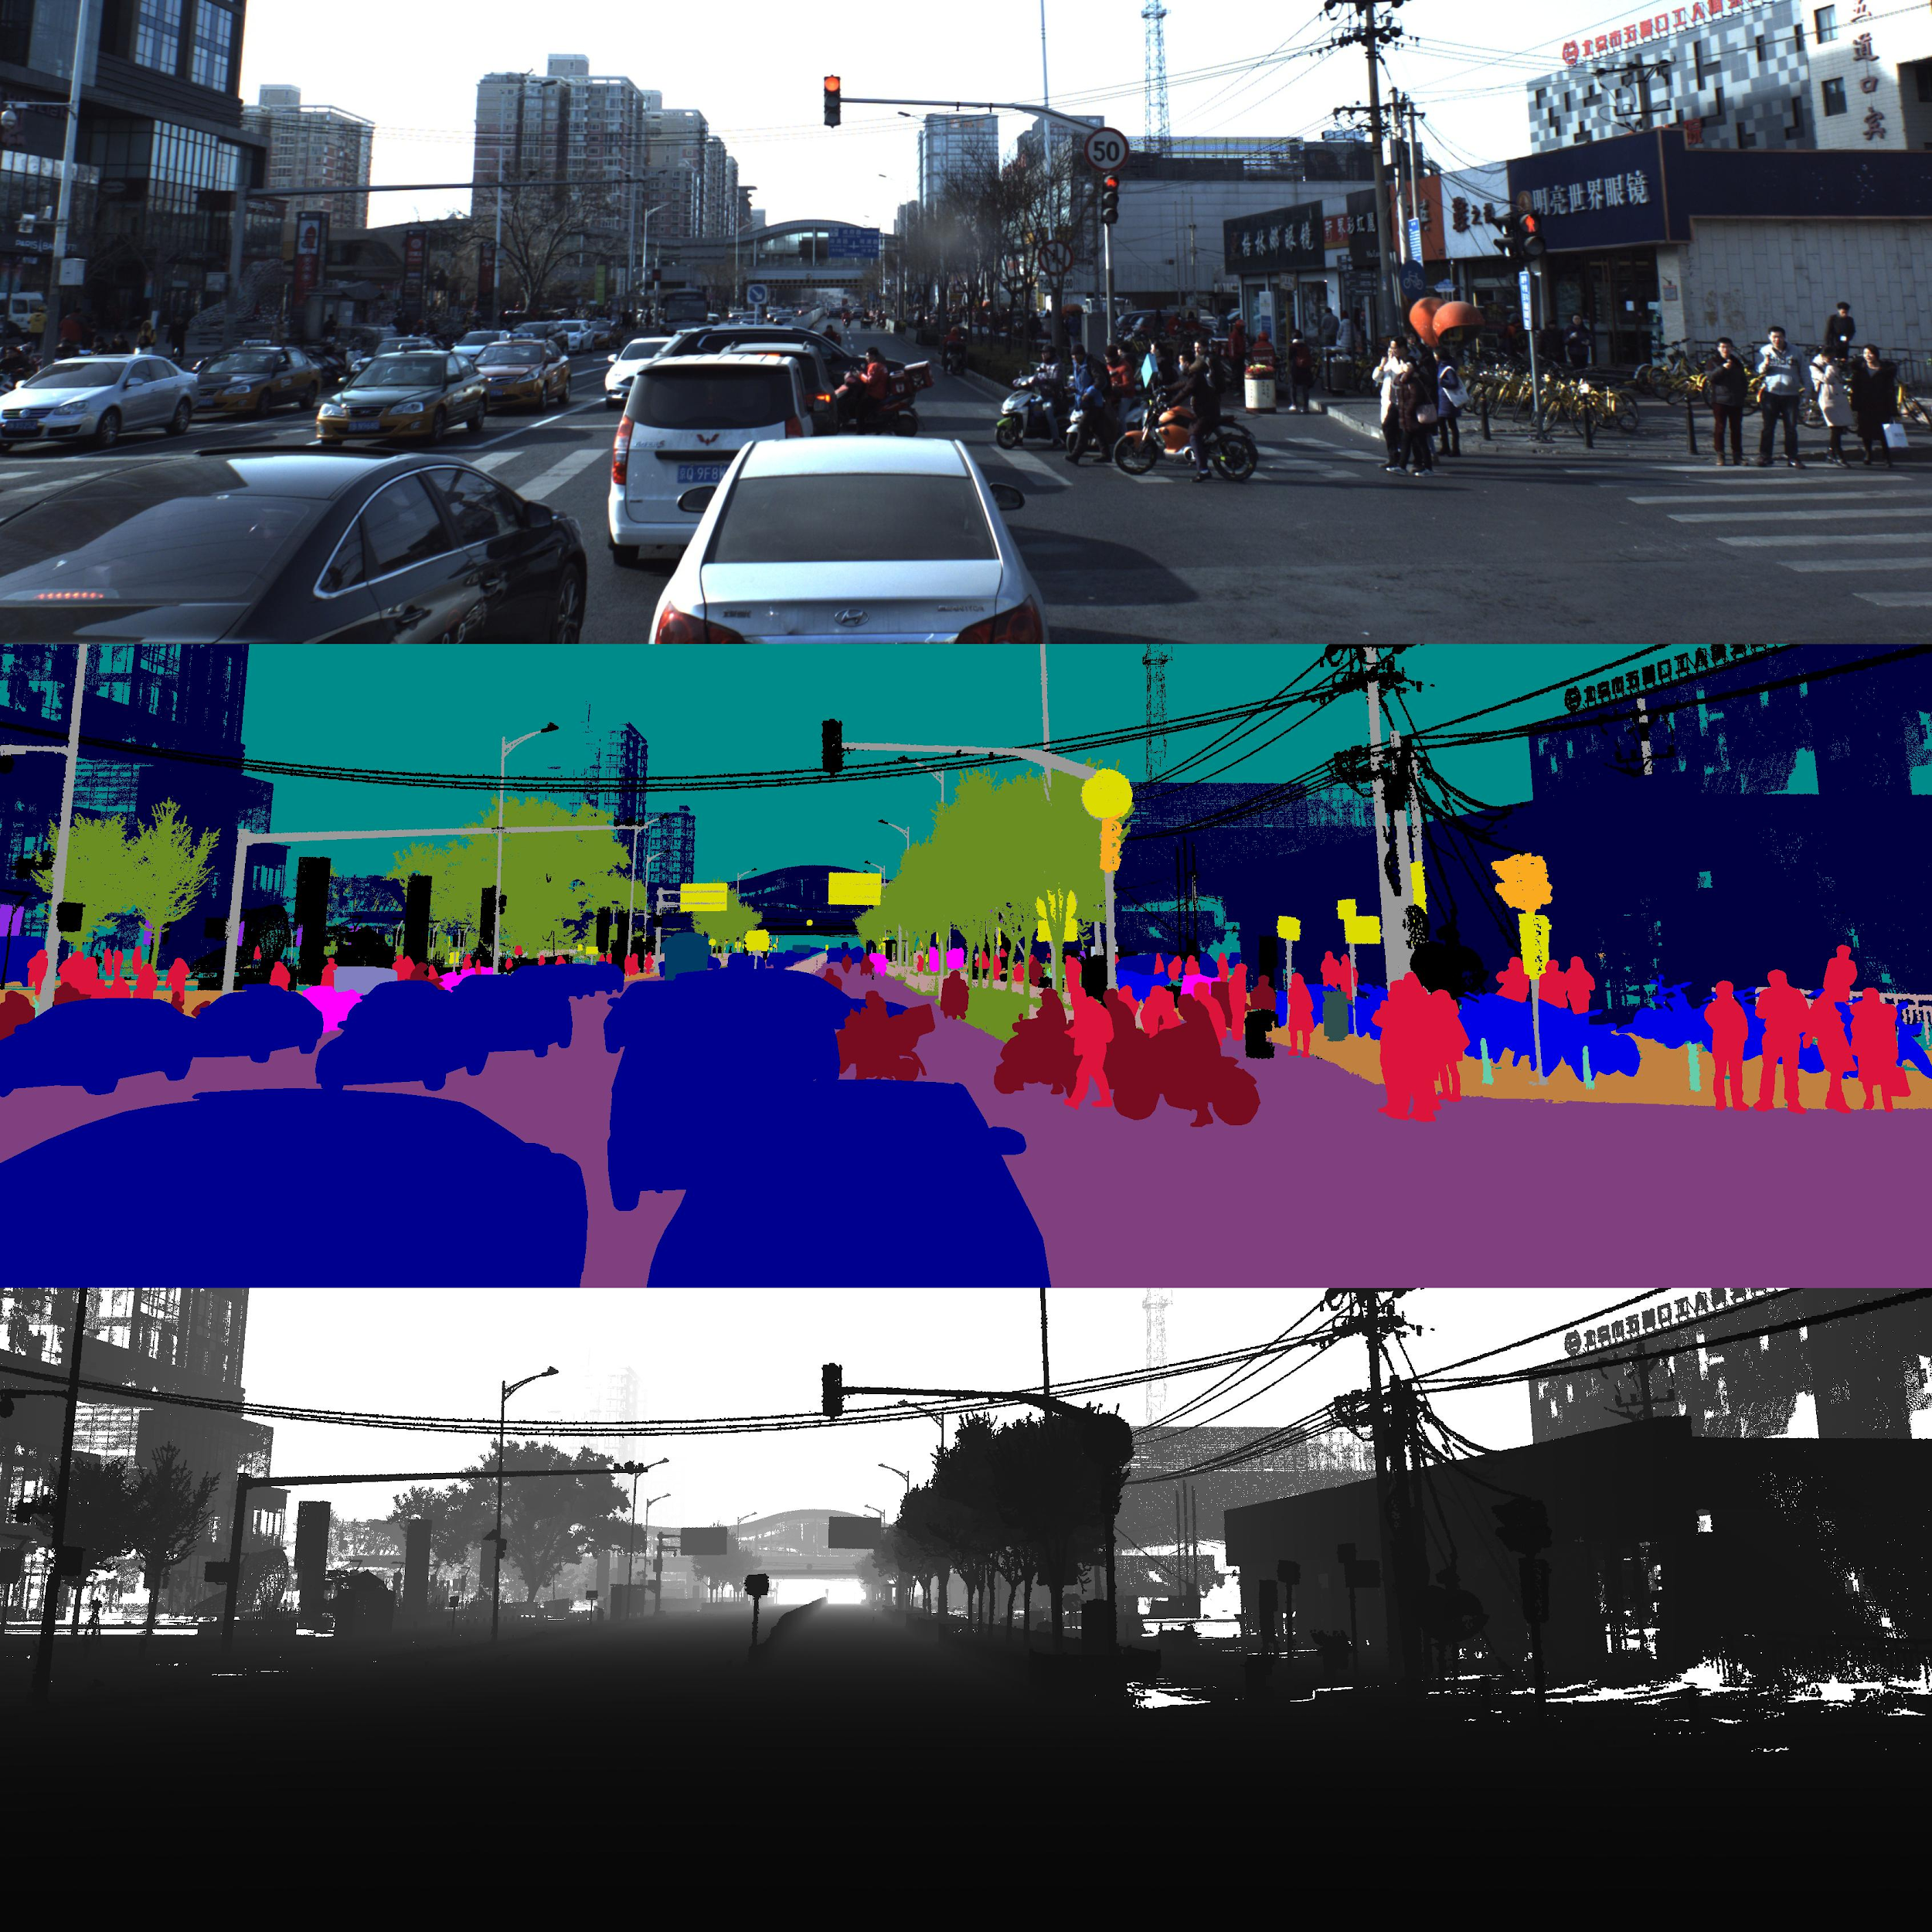

Sample Colored Image, Semantically segmented image and depth map

### Lane Segmentation(ApolloScape)

The segmentation results can be directly used for HD Maps construction or updating process.

**Data Structure :** Same as in scene parsing pixel level lane marking

**Labels :** 35 labels

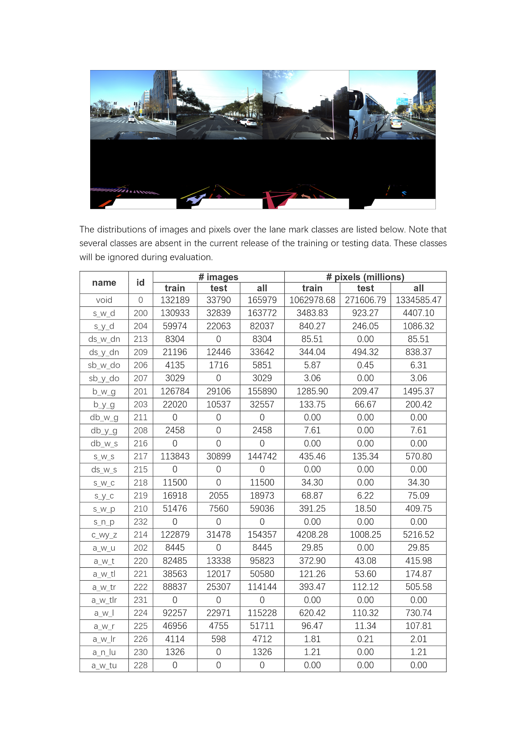

Sample Colored and label image

***2.2 YOLO***

YOLO is a new approach to object detection. Prior work on object detection repurposes classifiers to perform detection. Instead, YOLO frames object detection as a regression problem to spatially separated bounding boxes and associated class probabilities. A single neural network predicts bounding boxes and class probabilities directly from

full images in one evaluation. Since the whole detection pipeline is a single network, it can be optimized end-to-end directly on detection performance.

Our model has several advantages over classifier-based systems. It looks at the whole image at test time, so its predictions are informed by global context in the image. It also makes predictions with a single network evaluation unlike systems like [R-CNN](https://github.com/rbgirshick/rcnn) which require thousands for a single image. This makes it extremely fast, more than 1000x faster than R-CNN and 100x faster than [Fast R-CNN](https://github.com/rbgirshick/fast-rcnn).

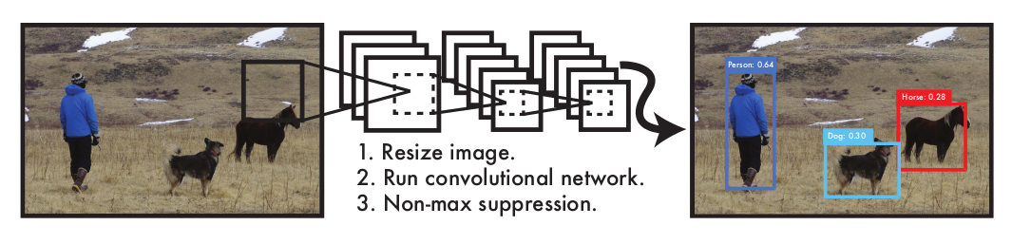

The YOLO Detection System. Processing images with YOLO is simple and straightforward. Our system (1) resizes the input image to 448 × 448, (2) runs a single convolutional network on the image, and (3) thresholds the resulting detections by the model’s confidence.

More recent approaches like R-CNN use region proposal methods to first generate potential bounding boxes in an image and then run a classifier on these proposed boxes. After classification, post-processing is used to refine the bounding boxes, eliminate duplicate detections, and rescore the boxes based on other objects in the scene. These complex pipelines are slow and hard to optimize because each individual component must be trained separately. YOLO reframes object detection as a single regression problem, straight from image pixels to bounding box coordinates and class probabilities. Using this system, you only look once (YOLO) at an image to predict what objects are

present and where they are.

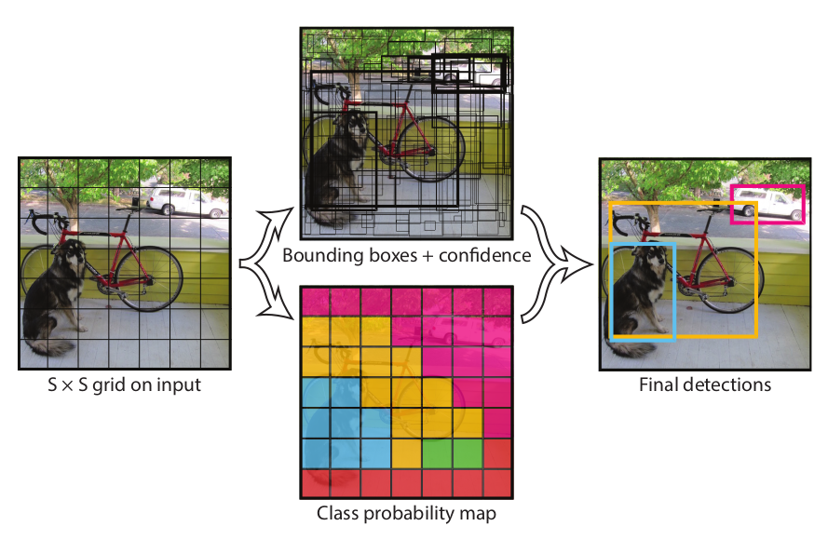

**The Model**- Our system models detection as a regression problem. It divides the image into an S × S grid and for each

grid cell predicts B bounding boxes, confidence for those boxes, and C class probabilities. These predictions are encoded as an S × S × (B ∗ 5 + C) tensor.

This network architecture is inspired by the GoogLeNet model for image classification. It network has 24 convolutional layers followed by 2 fully connected layers. Instead of the inception modules used by GoogLeNet, it simply uses 1 × 1 reduction layers followed by 3 × 3 convolutional layers. The full network is shown below-

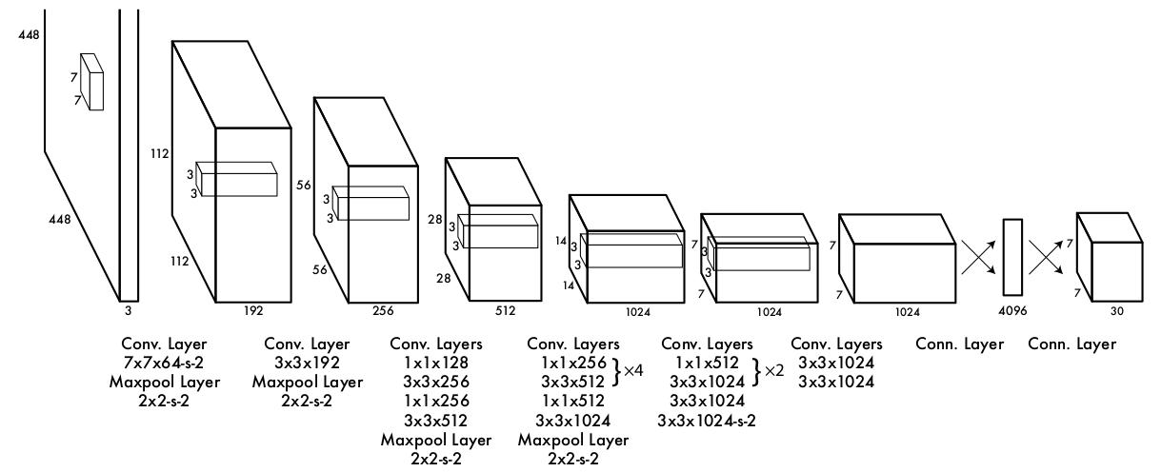

**The Architecture**- Our detection network has 24 convolutional layers followed by 2 fully connected layers. Alternating 1 × 1 convolutional layers reduce the features space from preceding layers. We pretrain the convolutional layers on the ImageNet classification task at half the resolution (224 × 224 input image) and then double the resolution for detection.

For more details, find YOLO published paper [here](https://github.com/GuptaAbhinavv/MapmyIndia/blob/master/YoloV3/YOLO.pdf).

### Pre-trained YOLO

Running pre-trained YOLO on sample images is easy and can be achieved by simple steps.

1. Clone the darknet repository from github and run make to produce the executable file - darknet.

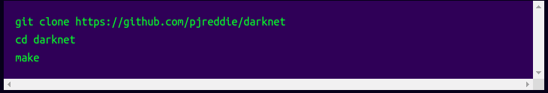

1. Download pre-trained weights using-

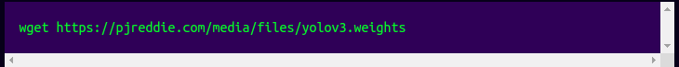

1. Run the detector-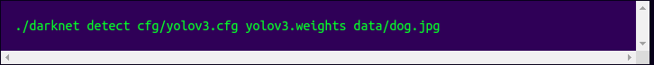

Expected Output -

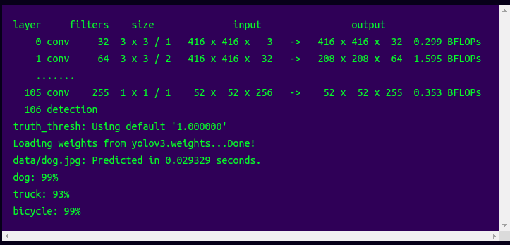

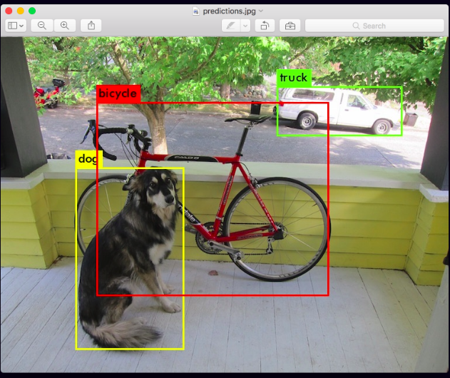

### YOLO for Custom Dataset

* **Data Collection and Annotation**

The YOLO format of labeling is as follows -

class_number box1_x1_ratio box1_y1_ratio box1_width_ratio box1_height_ratio

class_number box2_x1_ratio box2_y1_ratio box2_width_ratio box2_height_ratio

Let dW and dH be the inverse of the width and height of the image respectively.

If values xmin, xmax, ymin and ymax are known, the above values are given as-

1. x1_ratio = (xmin + xmax)/2 * dW
2. y1_ratio = (ymin + ymax)/2 * dH
3. width_ratio = (xmax - xmin) * dW
4. height_ratio = (ymax - ymin) * dH

* **Test and Train list**

Prepare separate text files with the list of names of test and train images in appropriate ratio.

* **Editing .cfg files**

This editing of the .cfg file involves-

1. Uncomment the lines 5,6, and 7 and change the training batch to 64 and subdivisions to 2.
2. Change the number of filters for convolutional layer "[convolution]" just before every yolo output "[yolo]" such that the number of filters= #anchors x (5 + #ofclasses)= 3x(5+1)= 18. The number 5 is the count of parameters center_x, center_y, width, height, and objectness Score. So, change the lines 127 and 171 to "filters=18".
3. For every yolo layer [yolo] change the number of classes to 1 as in lines 135 and 177.

Start training by using the command -



A sample output from a YOLOv3 trained on a custom dataset i.e. a snowman detector -

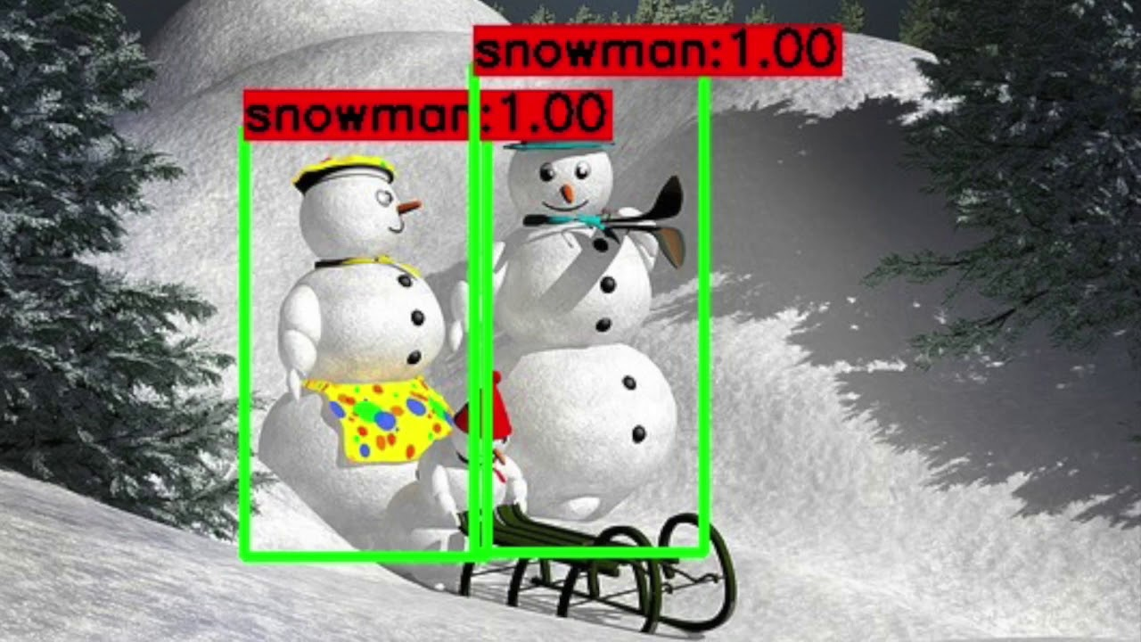

**References**

1. [J. Redmon, S. Divvala, R. Girshick, A. Farhadi. You Only Look Once: Unified, Real-Time Object Detection, 2016](https://arxiv.org/pdf/1506.02640.pdf)
2. [Xinyu Huang, Peng Wang, Xinjing Cheng, Dingfu Zhou, Qichuan Geng, Ruigang Yang. The ApolloScape Open Dataset for Autonomous Driving and its Application, 2019](https://arxiv.org/pdf/1803.06184.pdf)
3. [Xinyu Huang, Xinjing Cheng, Qichuan Geng, Binbin Cao, Dingfu Zhou, Peng Wang, Yuanqing Lin, and Ruigang Yang. The ApolloScape Dataset for Autonomous Driving, 2018](http://ad-apolloscape.bj.bcebos.com/public%2FApolloScape%20Dataset.pdf)
4. <http://apolloscape.auto/> - ApolloScape Website
5. <http://data.apollo.auto/> - Other Apollo Datasets
6. [Camera Calibration and 3D Reconstruction](https://docs.opencv.org/2.4/modules/calib3d/doc/camera_calibration_and_3d_reconstruction.html)
7. [Multiple View Geometry in Computer Vision. Second Edition. Richard Hartley, Andrew Zisserman.](http://cvrs.whu.edu.cn/downloads/ebooks/Multiple%20View%20Geometry%20in%20Computer%20Vision%20(Second%20Edition).pdf)